AWS Academy Cloud Foundations Notes
use ehostler@ycp.edu account for AWS Academy login

AWS Core Services

COMPUTE

EC2 – Elastic Compute Cloud – provides VM instance creation and management

Lambda – Serverless computing – containers, run code without setting up or provisioning servers, no charge when your code is not running

ELB – Elastic Load Balancing – distributes incoming traffic among EC2 instances
- Application Load Balancer (ALB) - distributes HTTP requests
- Network Load Balancer (NLB) – distributes TCP connections
- Classic Load Balancer (CLB) – for apps built in EC2-Classic network
- access apps through a single point (simplicity, better security)
- separate load balancers for external and internal requests (decoupling)
- provide high availability and fault tolerance
- increase elasticity and scalability
- ALB Listener can distribute traffic based on dest port number
- Listener distributes traffic to Target Groups
- NLB uses single static IP address per AZ
- LBs monitor instances using Health Checks
- LBs provide performance metrics for analysis

Auto Scaling – scales EC2 capacity as needed – automatically adds and removes EC2 instances to improve availability
- works with EC2 instances, DynamoDB tables and indexes, Aurora Replicas
- scales an Auto Scaling Group
- Scaling Out = launching instances
- Scaling In = terminating instances
- policies determine how scaling occurs
- registers new instances with load balancers
- can launch across AZs
- Launch Configuration – what is to be launched? Requires AMI, instance type, and a name
- Auto Scaling Group – where will it be launched? VPC, load balancer, min instances, max instances, desired capacity
- Auto Scaling Policy – when will it be launched? Scheduled, on demand, scale out policy, scale in policy
- CloudWatch + Auto Scaling + Elastic Load Balancing

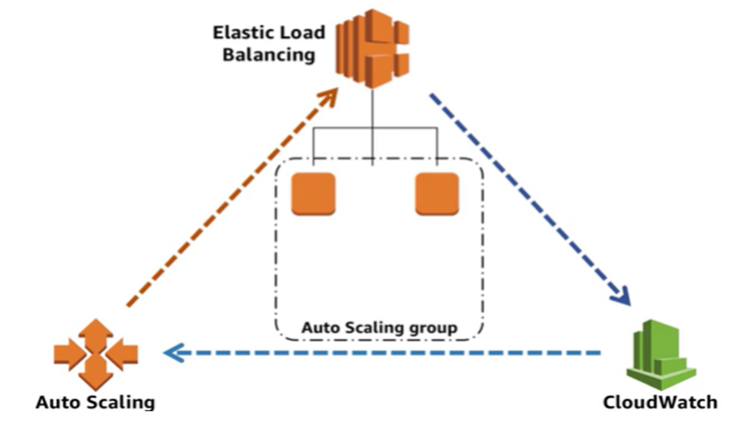

Elastic Beanstalk – PaaS that deploys, scales and manages web apps, no charge for Elastic Beanstalk, only the underlying AWS services used

EBS – Elastic Block Storage – block level storage volumes for VMs

Lightsail – PaaS for low cost simple web and app servers to quickstart a project

Elastic Container Services (ECS) – container mgmt service for Docker

Elastic Container Service for Kubernetes (EKS) – container mgmt service for Kubernetes

Fargate – add on for ECS and EKS that allows you to use containers without managing servers or clusters

STORAGE

EBS – Elastic Block Store – block level storage volumes for Vms
  - HDD, SSD and magnetic volume types
  - replicated in same AZ
  - easy encryption
  - elastic volumes can be resized without stopping the instances
  - can be backed up using snapshots

S3 – Simple Storage Service – cloud object storage – store any object / file in a “bucket” accessible via the web
S3 Storage Classes -
- Standard
- Standard Infrequent Access
- One Zone Infrequent Access
- Glacier

EFS – Elastic File System – shared NFS file storage that EC2 instances within the same VPC can access

Glacier – less expensive, slower access storage for archival storage of infrequently used data

NETWORK

VPC – Virtual Private Cloud – networking services IPAM, DNS (Route 53) and Amazon Security Groups (firewall like services)
- each VPC lives in a single Region
- VPCs in different Regions can be connected without using the Internet
- allowed multiple VPCs per account
- define an IP address range for the VPC
- IP address range cannot be changed after the VPC is created
- /16 max network size
- /28 min network size
- may span AZs within a Region
- VPCs are divided into subnets
- configure route tables to control traffic between subnets
- by default, all subnets in a VPC can communicate

Subnets – allow VPCs to span AZs within a Region
- subnets exist in a single AZ
- must route between subnets to cross AZ boundaries
- public – subnet has access to the Internet, directs traffic to the VPC’s Internet Gateway
- private – no access to the Internet, does not send traffic to the Internet Gateway
- VPN only – only sends traffic to the VPC’s Virtual Private Gateway
- first 4 addresses and last address reserved on every subnet for AWS internal use

Route Tables – configurable and can be used to control traffic, 1:M relationship 1 route table: M subnets, each subnet must be associated with a route table

DHCP option sets – automatically created for VPC when VPC created, sets the DNS server address and domain name

Security Groups – virtual stateful firewall for EC2 instances associated with the security group

NACL – Network Access Control Lists – optional virtual stateless firewall for associated subnets

Internet Gateway (IGW) – allows access to the Internet from a VPC

Elastic IP (EIP) Address – static public IP address that is allocated from a pool for temporary use

Elastic Network Interface (ENI) – virtual network interface that can be connected to an EC2 instance

Endpoint – direct connection to other AWS services

Peering – allows two VPCs to communicate

NAT Instances – Amazon Linux AMI to handle NAT for a private subnet

NAT Gateway – highly available managed NAT service for subnets within an AZ

AWS Hardware VPN – hardware VPN connection between your network and your VPC

AWS Direct Connect – dedicated private connection between your network and your VPC

AWS VPN CloudHub – multiple hardware VPN connections between your VPC and multiple remote networks

Software VPN – EC2 instance running a software VPN appliance

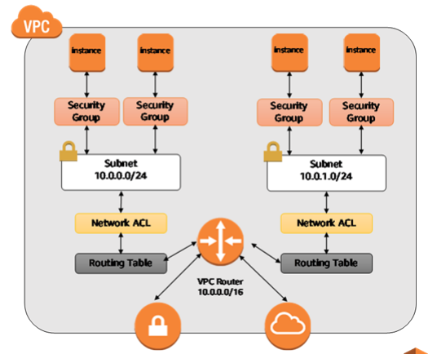

Virtual Private Gateway Internet Gateway

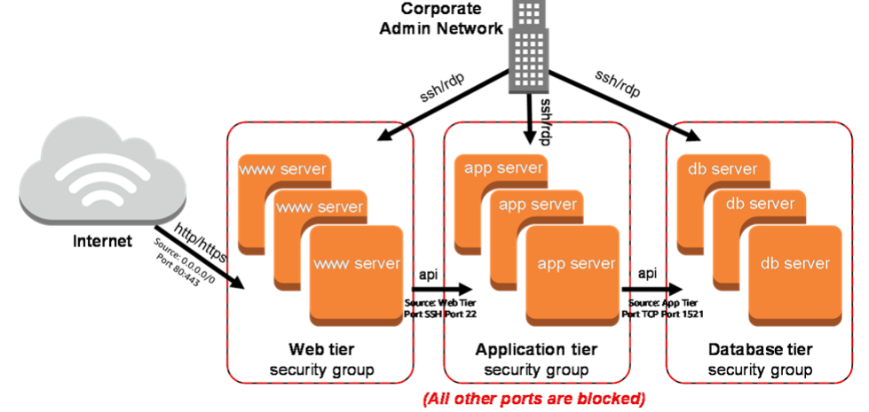

CloudFront – Global Content Delivery Network (CDN) that puts resources (content) at the network edge geographically close to the users independent of the location of the application and compute resources in the cloud

Route 53 – AWS DNS services

DATABASE

RDS – Relational Database Service – managed relation database
- database runs on an RDS DB Instance instead of an EC2 instance
- DB Instance Class allows you to specify instance size – CPU, Mem, network performance
- DB Instance Storage choices – magnetic, general purpose SSD, provisioned IOPS
- supported DB Engines
  - MySQL
  - Aurora
  - SQL Server
  - PostgreSQL
  - MariaDB
  - Oracle
- automatically creates a standby instance in another AZ
- synchronous data replication to the standby instance
- automatic fail-over to the standby instance
- read replica instances also supported (uses asynchronous replication)
- read replicas can be used to improve performance on read intensive applications by spreading the request load between the master instance and the read replica instance
- use cases
  - high throughput
  - massive storage scalability
  - high availability
  - low cost
  - data security
  - fully managed
  - rapidly grow capacity
  - automatic scaling
  - database monitoring
  - up to 30K IOPS

Redshift – managed data warehouse service
- analyze data using SQL and standard BI applications
- parallel processing of queries
- leader nodes – break down complex queries and assign query tasks to compute nodes
- compute nodes – perform assigned tasks and return results to leader node
- encryption of data at rest and in transit
- provides ODBC and JDBC connections
- use cases – Enterprise Data Warehouse, Big Data

DynamoDB - fully managed NoSQL database service
- based on tables, items and attributes
- no table size or throughput limits
- items in the same table can have different attributes
- low latency
- scalable read/write throughput
- global tables – replicates tables across Regions
- encryption at rest
- two types of primary keys
  - Partition Key
  - Partition and Sort Key (composite key)
- query uses key to find items
- scan finds items by any attribute

Aurora – managed relational DB service compatible with mySQL and PostgreSQL, with better performance and replication across AZs
stores 6 copies of the data across 3 AZs

ElastiCache – caches frequently used data from the DB in RAM for better performance

CloudFormation – automation tool that provides infrastructure as code, your AWS infrastructure is defined in a single JSON text file that can be managed with version control

CloudWatch – gathers metrics on utilization and performance of resources in your AWS infrastructure to help you manage those resources effectively
- monitors usage but does not add or remove resources
- track resource and application performance
- collect and monitor log files
- notifications when events occur
- basic monitoring – seven EC2 metrics at 5 minute intervals, 3 at 1 minute intervals, no charge
- detailed monitoring – all EC2 metrics at 1 minute intervals and data aggregation by AMI ID and instance type, provided at additional charge
- metrics – a specified data point
- alarm – sends out notification when a tracked metric reaches a specified value for a specified period of time
- events – monitors AWS resources and provides real time stream of events that describe the changes in resources
- Alarm Actions
  - stop, terminate, reboot or recover and instance
  - scale an auto scaling group in or out
  - send message
- metric data kept for 15 months
IAM – Identity and Access Management – user accounts, roles and permissions
- global – applies across all Regions
- root account provides access to all functions and services related to an AWS account
- create an IAM account with administrative privileges to manage AWS rather then use the root account
- policies are collections of permissions
- policies are used to grant authorization
- all permissions are denied by default
- only permissions explicitly assigned by a policy will be granted
- IAM policies are stored in JSON format
- policies can be attached to any IAM entity - user, group, role or resource
  - identity based policy – attached to user, group or role
  - resource based policy – attached to a resource i.e. an S3 bucket
- policy application order does not effect outcome
- most restrictive policy is always applied
- multi-factor authentication (MFA) is an optional services
  - hardware devices or MFA compliant applications (like Google Authenticator)
  - SMS – text messages with access codes
- IAM users can be applications that need specific permissions rather than people
- groups cannot be nested
- there is no “everyone” group unless you create it and maintain it
- roles allow temporary access to perform an action when a security principle “assumes” the role
- roles include trust policies and access policies
  - trust policies determine who or what may assume the role
  - access policies determine what the role is allowed to do

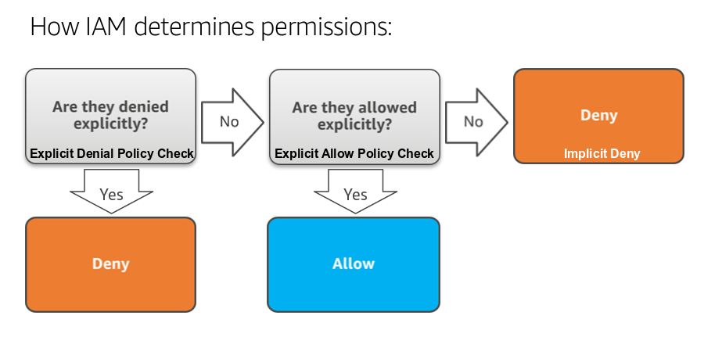

Trusted Advisor – auditing tool to help reduce cost, improve performance and improve security
Five Categories -
  - Cost Optimization
  - Performance
  - Security
  - Fault Tolerance
  - Service Limits

Color codes -
  - Red – action recommended
  - Yellow – investigation recommended
  - Green – no problem detected

Trusted Advisor best practices -
  - Service Limits
  - Security Groups – Specific Ports Unrestricted
  - IAM Use
  - Multi-Factor Authentication on Root Account
  - Elastic Block Store Public Snapshots
  - Relational Database Service Public Snapshots

Cost Explorer – tracks costs for last 13 months, forecasts for next three months, view data by day or month

CloudTrail – governance, compliance, operational auditing and risk auditing
- integrating CloudTrail with CloudWatch provides comprehensive, secure and searchable event history of activities in your AWS account
- best practices -
  - turn on CloudTrail log file validation
  - aggregate log files to a single S3 bucket
  - ensure that it is enabled across AWS globally
  - restrict access to CloudTrail S3 buckets
  - integrate with CloudWatch

Config – assess, audit and evaluate the configurations of AWS resources
- continuous monitoring
- continuous assessment
- change mgmt
  - complete AWS resource inventory
  - configuration history (how any resource was configured at any point in time)
  - configuration change notifications
- operational troubleshooting

AWS Day One Security Best Practices

- Stop using the root account
- Require Multi-Factor Authentication for access (especially for the root account)
- Enable CloudTrail
- Enable a billing report

Important Cloud Terminology

- High Availability – accessible when you need it
- Fault Tolerance – ability to withstand a certain amount of failure and remain functional
- Scalability – ability to grow in size, capacity, and/or scope when required
- Elasticity – ability to grow when required and reduce in size when resources are no longer needed

6 Advantages of Cloud Computing

- CapEx to OpEx (Variable Expense)
- Economies of Scale
- Stop guessing about IT Capacity
- Speed and Agility
- Spend Strategically - stop spending money on running and maintaining data centers
- Ease of Deployment – go global in minutes

AWS Cloud Adoption Framework (CAF) Perspectives

- Business
- People
- Governance
- Platform
- Security
- Operations

Reserved Instances (RIs)

All Up-front Reserved Instance – pay in advance, largest discount
Partial Up-front Reserved Instance – pay some in advance, lower discount
No Upfront Payments Reserved Instance – pay nothing in advance, smallest discount

Pay Less when you use More

Tiered pricing – the more you use, the less you pay per GB
Multiple services – select a service that meets your performance and cost requirements
Economies of Scale – AWS growth and technology improvements drive costs down, AWS has lowered pricing 61 times since 2006
Custom Pricing – custom pricing for large projects with unique requirements

No Charge Services

- free inbound data transfer for EC2 instances
- free inbound data transfer to S3
- free outbound data transfer between Amazon Web Services within the same region
- free outbound data transfer from S3 to CloudFront
- VPC
- IAM
- Consolidated Billing
- Elastic Beanstalk
- CloudFormation
- Automatic Scaling
- OpsWorks
- In-bound data transfer

AWS Simple Monthly Calculator
AWS TCO Calculator

Amazon RDS Pricing

- clock-hour billing
- database characteristics – DB engine, size, memory class effect pricing
- DB purchase type – on demand, reserved instances
- number of DB instances
- provisioned storage – no charge backup storage, backups for terminated instances charged by GB/month
- additional storage – charged by GB/month
- requests – number of input and output requests
- deployment type – single vs. multiple AZs
- data transfer – no charge for inbound transfer, tiered charges for outbound

Storage Pricing

- EBS Volumes are charged by the amount of storage
- You pay for the amount of storage even if the EC2 instance is not running
- General Purpose SSD storage is charged in GB per month
- Magnetic storage is charged by the number of requests to the volume
- Provisioned IOPS is charged by the amount you provision by % of day/month used
- Snapshots are charged per GB per month stored, and storage class
- S3 storage is charged by GB/month, data transfer out of the region where the S3 bucket resides, and web requests (PUT, COPY, POST, LIST and GET)

EC2 Pricing

- On-Demand Instances
  - flexibility
  - short term or unpredictable workloads
- Spot Instances
  - spot price based on supply and demand
  - can bid for unused EC2 capacity
  - apps with flexible start and stop times
  - apps only feasible at very low compute prices
  - urgent need for large amounts of additional capacity
- Reserved Instances
  - steady state or predictable workloads
  - apps that require reserved resources like disaster recovery
  - up front payments to lower costs
- Dedicated Hosts
  - for meeting compliance and regulatory requirements
  - bring your own license
  - control instance placement
  - on demand or reserved instances

Per-second billing for Amazon Linux and Ubuntu (60 sec minimum)
Per-hour billing for all other OSs
Per-hour billing only for Dedicated Hosts

- Clock hours of server time
- Instance configuration – pricing varies with Region, OS, Num of cores, memory
- Type of instance – on demand, spot, reserved
- Number of instances
- Load balancing – hours the load balancer runs and data the load balancer processes determine cost
- Use CloudWatch to monitor instances – basic monitoring free, detailed monitoring incurs fees
- Auto Scaling – adjusts the number of instances running
- Elastic IP addresses – no charge for one Elastic IP per instance
- Pricing for OS and software packages (SQL Server, etc)

Cost Optimization

- Right Sizing
- Reserved Instances
- Increase Elasticity
- Monitor and Improve

AWS Global Infrastructure

Regions
- a geographical area
- contain 2 or more Availability Zones
- 18 regions worldwide
- AWS never moves or duplicates your data outside of the Region it resides in, you must configure that if necessary
- communication between Regions uses the AWS Backbone

Availability Zones
- contain one or more Data Centers
- designed for fault isolation
- connected with other AZs using private links
- each data center’s power comes from a separate power grid
- recommended to replicate resources across AZs for resiliency

Edge Locations
- where end users access AWS services
- 114 points of presence
- 56 cities
- 24 countries
- used with CloudFront to deliver content

